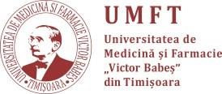
MINIMUM WAGES

Associate professor – 4807 lei
University professor – 5643 lei

